MISSOURI UNIFORM CRIME REPORTING PROGRAM

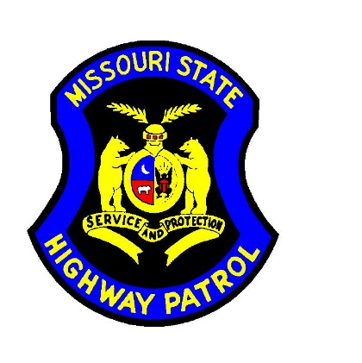

USE OF FORCE
DATA COLLECTION
GUIDELINES

Version 2.1
02/22/2023

Contents
Trainer Contact Information: 3
Background 4
Reporting Requirements 5
Definitions 5
Peace Officer: 5
Serious Bodily Injury: 5
Login 6
Incident Details 8
Owning Agency ORI (Data Element I1) 8
Different Reporting ORI (Data Element I4) 8
Agency Case Number (Data Element I2) 8
Incident Date (Data Element I3) 8
Incident Time (Data Element I5 & I6) 8
Location Type (Data Element I7) 9
Ambush (Data Element I12) 10
Officer Approach (Data Element I13) 10
Senior Officer Present (Data Element 14) 10
Total Officers Status (Data Element I28) 10
Total Officers Involved (Data Element I9) 11
Subject Status (Data Element I29) 11
Agency Officers Status (Data Element I30) 11
Incident Tickler (Type) (Data Element I32) 11
Initial Contact (Data Element I8) 12
Number of Offenses (Data Elements 15 to 17) 12
Offense 1, Offense 2, Offense 3 (Data Elements 15 – 17) 12
Other Agencies Involved (Data Element I10) 14
Address (Data Elements I18-I21) 14
Subjects Involved (Data Element I33) 14
Agency Officers Involved (Data Element I30) 14
Subject Details 15
Subject Age (Data Element S4) 15
Subject Height (Feet & Inches) (Data Elements S8 & S9) 15
Subject Weight (Data Element 14) 15
Subject Race/Ethnicity (Data Element S2) 15
Subject Gender/Sex (Data Element S3) 16
Impairment (Data Element S18) 16
Resisted (Data Element 20) 17
Threatened (Data Element 22) 18
Armed (Data Element 23) 18
Force Applied (Data Element 24) 18
Injury Type (Data Element 25) 19
Officer Details 20
Officer Age (Data Element O4) 20
Officer Height (Feet & Inches) (Data Elements O6 & O7) 20
Officer Weight (Data Element O9) 20
Officer Race/Ethnicity (Data Element O2) 20
Officer Gender/Sex (Data Element O3) 21
Officer Years of Service (Data Element O11) 21
Full Time (Data Element O13) 21
Identifiable (Data Element O14) 21
On Duty (Data Element O15) 21
Injury Type (Data Element O16) 22
Shots Fired (Data Element O20) 22
Uploading an RMS generated file. 23
Submission and Error Correction 26

Trainer Contact Information:

Troop | Trainer | Phone | Email
Troop A | Kevin Neeley | 573-526-6153 ext. 2632 | Kevin.Neeley@mshp.dps.mo.gov
Troop A | Jay Mauthe | 573-526-6153 ext. 2816 | Jay.Mauthe@mshp.dps.mo.gov
Troop B & H | Kerri Smith | 573-526-6153 ext. 3190 | Kerri.Smith@mshp.dps.mo.gov
Troop C | Deven Boyd | 636-300-2800 ext. 6827 | Deven.Boyd@mshp.dps.mo.gov
Troop C | Chelsea Kincaid | 636-300-2800 ext. 6805 | Chelsea.Kincaid@mshp.dps.mo.gov
Troop D | Jenee' Peryer | 417-895-6868 ext. 6412 | Jenee.Peryer@mshp.dps.mo.gov
Troop D | Matt Owens | 573-526-6153 ext. 2628 | Matt.Owens@mshp.dps.mo.gov
Troop E | Scott Cline | 417-469-3726 ext. 3761 | Scott.Cline@mshp.dps.mo.gov
Troop F | John Rollins | 573-526-6153 ext. 2634 | John.Rollins@mshp.dps.mo.gov
Troop G & I | Jordan Eichholz | 573-526-6153 ext. 2676 | Jordan.Eichholz@mshp.dps.mo.gov
Program Manager | Stephanie Vert | 573-526-6278 ext. 2605 | Stephanie.Vert@mshp.dps.mo.gov

Background

The 2021 session of the General Assembly passed Revised Statute of Missouri 590.1265, Police Use of Force Transparency Act of 2021, which specifies the reporting requirement for all Peace Officers’ Use of Force (UoF) Incidents. This statute began the process of collecting data related to fatalities and serious bodily injuries as a result of interaction with law enforcement. The law requires all law enforcement agencies in the State of Missouri to report Use of Force Data beginning March 1, 2022 to the Missouri Department of Public Safety.
The Department of Public Safety has tasked the Missouri Uniform Crime Reporting Program administered by the Missouri State Highway Patrol with the collection of this data. The Missouri State Highway Patrol’s Criminal Justice Information Systems (CJIS) Division’s Technical Systems Training and Auditing Section are responsible for the day to day administration of this data.
As of January 1, 2019, the FBI has established the National Use-Of-Force Data Collection.
The law enforcement community, in partnership with the FBI, is working to improve the way the nation collects, analyzes, and uses crime statistics about law enforcement’s use of force.
The Missouri and National Use-of-Force Data Collection will include incident information, subject information, and officer information. These events include:
- When a fatality to a person occurs connected to use of force by a law enforcement officer
- When there is serious bodily injury to a person connected to use of force by a law enforcement officer
- In the absence of either death or serious bodily injury, when a firearm is discharged by law enforcement at or in the direction of a person

As of March 01, 2022, the MSHP MIBRS repository on the Show Me Crime webpage (www.showmecrime.mo.gov) has opened a Use-of-Force Module. Each law enforcement agency may select a contact person responsible for entering Use-Of-Force data. This person may be an MIBRS Representative or other agency personnel.

The following information will assist agencies in the manual web entry and navigation of the Use-Of-Force Module in the Crime Reporting (mo.gov) MSHP MIBRS repository.

Reporting Requirements

Responsibility for submitting Use-Of-Force data falls to the agency that employs the officer(s) who used force, rather than the agency that is investigating the case. (For example, if MSHP investigates Agency X Police Departments officer’s use-of-force, but Agency X Police Department will still be responsible for the data submission).

Officer Involved Shooting (OIS) Investigated by MSHP
Local LEA will: | MSHP will:
Submit UOF data to repository | Enter case in MSHP RMS as primary/lead for officer-involved shooting investigation
Enter case involving subject in local RMS
(include offenses committed by offender)

OIS Investigated by Originating Agency
Local LEA will:
Submit UOF data to repository
Enter case involving subject in local RMS (include offenses committed by offender)
Enter separate officer-involved shooting case in RMS as primary/lead

Definitions

Peace Officer:

Based on FBI UCR Law Enforcement Officer Assaulted and Killed data collection definition:

All local, county, state, and federal law enforcement officers (such as municipal, county police officers, constables, state police, highway patrol, sheriffs, their deputies, federal law enforcement officers, marshals, special agents, etc.) who are sworn by their respective government authorities to uphold the law and to safeguard the rights, lives, and property of American citizens.

They must have full arrest powers and be members of a public governmental law enforcement agency, paid from government funds set aside specifically for payment to sworn police law enforcement organized for the purposes of keeping order and for preventing and detecting crimes, and apprehending those responsible.

Serious Bodily Injury:

Based in part on Title 18 US Code Section 2246(4), “Serious Bodily Injury” means bodily injury that involves:
• a substantial risk of death,
• unconsciousness,
• protracted and obvious disfigurement, OR
• protracted loss or impairment of the function of a bodily member, organ, or mental faculty.

Examples of “Serious Bodily Injury” include, but are not limited to, the following:
• broken/fractured bones
• gunshot wounds (including minor or grazing wounds)
• loss of consciousness (regardless of duration)
• severe lacerations
• internal injury
• life threatening injury
• other serious injury requiring medical intervention or hospitalization

Login
Step 1: Log in to the MSHP Crime Insight Repository (showmecrime.mo.gov)

Step 2: Select ‘Web Entry’ and the dropdown ‘Use of Force’

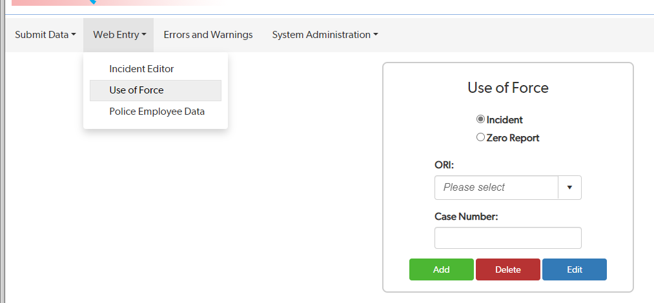

The following screen will appear.
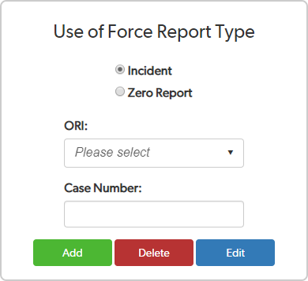

Step 3: Select Report Type – Incident Report vs. Zero Report

  - If your agency did not have any qualifying UoF Incidents to report in a month;
    - Select ‘Zero Report’
    - Select Month & Year
    - Select ‘Add’
  - If your agency has a Use-Of-Force incident to report, follow the remaining instructions Step 4: Enter Agency ORI
Step 5: Enter Case/Incident Number

Step 6: Select appropriate action.

  - Select ‘Add’ to enter a new Use of Force incident
  - Select ‘Delete’ to remove a previously submitted incident.
  - Select ‘Edit’ to update a previously submitted incident Enter the information below using the dropdown selections
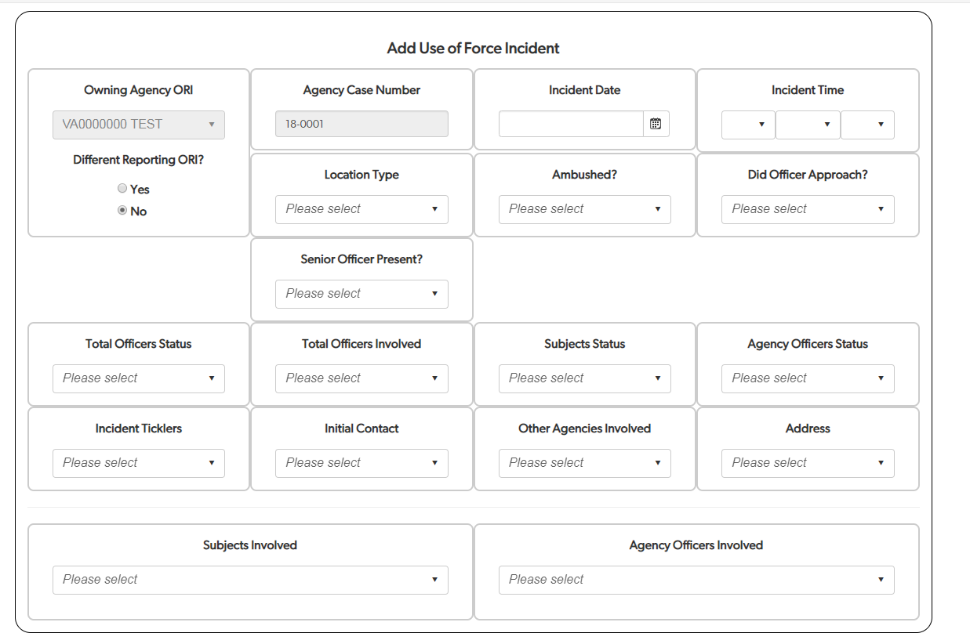

Incident Details

Owning Agency ORI (Data Element I1)

Incident owning agency Originating Agency Identifier. The value is an alphanumeric ORI of nine (9) characters in length.

Different Reporting ORI (Data Element I4)

Indicate the ORI for the agency reporting the Use-of-Force incident to the FBI.
**This data element is not used as the reporting of incident for an agency by another agency is not allowed.

Agency Case Number (Data Element I2)
Indicate the agency’s case number for the Use-of-Force incident.

Incident Date (Data Element I3)

Indicate the date the Use-of-Force incident occurred.

Incident Time (Data Element I5 & I6)

Indicate the hour and minute of time reflecting the best estimate of when the interaction between law enforcement and the subject occurred.

Location Type (Data Element I7)
Indicate the type of location/premises where the Use-of-Force incident took place.
Location Values
Air/Bus/Train Terminal (1)
Bank/Savings and Loan (2)
Bar/Nightclub (3)
Church/Synagogue/Temple/Mosque (4)
Commercial/Office Building (5)
Construction Site (6)
Convenience Store (7)
Department/Discount Store (8)
Drug Store/Doctor’s Office/Hospital (9)
Field/Woods (10)
Government/Public Building (11)
Grocery/Supermarket (12)
Highway/Road/Alley/Street/Sidewalk (13)
Hotel/Motel/Etc. (14)
Jail/Prison/Penitentiary/Corrections Facility (15)
Lake/Waterway/Beach (16)
Liquor Store (17)
Parking/Drop Lot/Garage (18)
Rental Storage Facility (19)
Residence/Home (20)
Restaurant (21)
Service/Gas Station (23)
Specialty Store (24)
Abandoned/Condemned Structure (37)

Location Values
Abandoned/Condemned Structure (37)
Amusement Park (38)
Arena/Stadium/Fairgrounds/Coliseum (39)
ATM (Automated Teller Machine) Separate from Bank (40)
Auto Dealership New/Used (41)
Camp/Campground (42)
Daycare Facility (44)
Dock/Wharf/Freight/Modal Terminal (45)
Farm Facility (46)
Gambling Facility/Casino/Race Track (47)
Industrial Site (48)
Military Installation (49)
Park/Playground (50)
Rest Area (51)
School–College/University (52)
School–Elementary/Secondary (53)
Shelter–Mission/Homeless (54)
Shopping Mall (55)
Tribal Lands (56)
Community Center (57)
Other
Pending further investigation
Unknown and is unlikely to ever be known

Ambush (Data Element I12)

Indicate if the incident involved an ambush of a law enforcement official. An ambush is defined as the act of attacking a person unexpectedly from a concealed station.

Value | Description
YES | Yes
NO | No
PENDING | Pending further investigation
UNKNOWN | Unknown and is unlikely to ever be known

Officer Approach (Data Element I13)

Indicate if the law enforcement official approached the subject.

Value | Description
YES | Yes
NO | No
PENDING | Pending further investigation
UNKNOWN | Unknown and is unlikely to ever be known

Senior Officer Present (Data Element 14)

Indicate if a supervisor or senior officer acting in a similar capacity was present or consulted prior to when force was used during the incident. Does not include an officer who has more experience and not in a supervisory role.

YES | Yes
NO | No
PENDING | Pending further investigation
UNKNOWN | Unknown and is unlikely to ever be known

Total Officers Status (Data Element I28)

Indicate if the number of officers that applied force from all responding agencies is known, unknown, or pending investigation.

Value | Description
PENDING | Pending further investigation
UNKNOWN | Unknown and is unlikely to ever be known
KNOWN | Known

Total Officers Involved (Data Element I9)

Indicate the total number of officers from all responding agencies who used force during the incident. Data value is a numeric with a minimum value of one.

Subject Status (Data Element I29)

Indicate if the number of subjects against whom force was applied is known, unknown, or pending investigation.

Value | Description
PENDING | Pending further investigation
UNKNOWN | Unknown and is unlikely to ever be known
KNOWN | Known

Agency Officers Status (Data Element I30)

Indicate if the number of officers from your agency who actually applied force during the incident is known, unknown, or pending investigation.

Value | Description
PENDING | Pending further investigation
UNKNOWN | Unknown and is unlikely to ever be known
KNOWN | Known

Incident Tickler (Type) (Data Element I32)

Indicate if the incident resulted in the following:

  - Death
  - Serious bodily injury due to law enforcement use-of-force
    - The definition of serious bodily injury will be based, in part, upon Title 18, United States Code, Section 2246 (4). The term “serious bodily injury” means “bodily injury that involves a substantial risk of death, unconsciousness, protracted and obvious disfigurement, or protracted loss or impairment of the function of a bodily member, organ, or mental faculty.”
  - Discharge of a firearm by a law enforcement officer at or in the direction of a person

Initial Contact (Data Element I8)

Indicate the reason behind the initial contact between the Law Enforcement Officer and the subject.

Contact Type | Contact Type Description
COURT_ORDER | Service of a court order
CRIMINAL_SUSPICIOUS_ACTIVITY* | Response to unlawful or suspicious activity*
DEMONSTRATION | Mass Demonstration
FOLLOWUP | Follow up investigation
MEDICAL | Medical, mental health, or welfare assistance
OTHER | Other
PENDING | Pending further investigation
ROUTINE_PATROL | Routine patrol other than traffic stop
TRAFFIC_STOP | Traffic Stop
UNKNOWN | Unknown and is unlikely to ever be known
WARRANT | Warrant Service
*If initial contact is based on ‘criminal suspicious activity’ the following fields will appear.
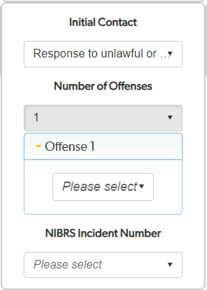

Number of Offenses (Data Elements 15 to 17)

Indicate the number of offenses committed that led to initial contact.

Offense 1, Offense 2, Offense 3 (Data Elements 15 – 17)

If the use-of-force was in response to report or observation of “unlawful or suspicious activity”, indicate the most serious observed offense(s) committed by the subject(s) prior to or at the time of the incident. Up to 3 offenses may be listed. The available offenses are listed on the following page. Then, enter the NIBRS Incident Number associated with these offenses.

GROUP A OFFENSE | CODE
Murder & Nonnegligent Manslaughter | 09A
Negligent Manslaughter | 09B
Justifiable Homicide | 09C
Aggravated Assault | 13A
Simple Assault | 13B
Intimidation | 13C
Human Trafficking, Commercial Sex Acts | 64A
Human Trafficking, Involuntary Servitude | 64B
Kidnapping/Abduction | 100
Rape | 11A
Sodomy | 11B
Sexual Assault With An Object | 11C
Fondling | 11D
Incest | 36A
Statutory Rape | 36B
Arson | 200
Bribery | 510
Burglary/Breaking & Entering | 220
Counterfeiting/Forgery | 250
Destruction/Damage/Vandalism of Property | 290
Embezzlement | 270
Extortion/Blackmail | 210
False Pretenses/Swindle | 26A
Credit Card/Automated Teller Machine Fraud | 26B
Impersonation | 26C
Welfare Fraud | 26D

GROUP A OFFENSE | CODE
Wire Fraud | 26E
Identity Theft | 26F
Hacking/Computer Invasion | 26G
Pocket-picking | 23A
Purse-snatching | 23B
Shoplifting | 23C
Theft from Building | 23D
Theft from Coin-Operated Machine or Device | 23E
Theft from Motor Vehicle | 23F
Theft of Motor Vehicle Parts or Accessories | 23G
All Other Larceny | 23H
Motor Vehicle Theft | 240
Robbery | 120
Stolen Property Offenses | 280
Drug/Narcotics Violations | 35A
Drug Equipment Violations | 35B
Betting/Wagering | 39A
Operating/Promoting/Assisting Gambling | 39B
Gambling Equipment Violations | 39C
Sports Tampering | 39D
Pornography/Obscene Material | 370
Prostitution | 40A
Assisting or Promoting Prostitution | 40B
Purchasing Prostitution | 40C
Weapons Law Violations | 520
Animal Cruelty | 720

GROUP B OFFENSE | CODE
Bad Checks | 90A
Curfew/Loitering | 90B
Disorderly Conduct | 90C
DUI | 90D
Drunkenness (DIP) | 90E

GROUP B OFFENSE | CODE
Family Offenses, Nonviolent | 90F
Liquor Law Violations | 90G
Peeping Tom | 90H
Trespass of Real Property | 90J
All Other Offenses | 90Z

For definitions of each code, please view the FBI User Manual V2021.1 located on the Crime Insight home
page, MIBRS Reporting Resources tab.
https://showmecrime.mo.gov/CrimeReporting/CrimeReporting.html

Other Agencies Involved (Data Element I10)

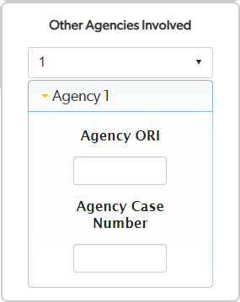
Indicate number of other agencies involved whose officer(s) applied force during the incident. Select ‘0’ if there were no other agencies involved whose officer(s) applied force.

Address (Data Elements I18-I21)

Indicate if the address of the incident is known, unknown or pending.

Value | Description
PENDING | Pending further investigation
UNKNOWN | Unknown and is unlikely to ever be known
KNOWN | Known

If the address of the incident is known, indicate the exact address (street, city, state, zip) or coordinates.

Subjects Involved (Data Element I33)

Indicate number of subjects involved in the incident. Include only those against whom force was applied.

Agency Officers Involved (Data Element I30)

Indicate number of officers from your agency who actually applied force in the incident.

Subject Details
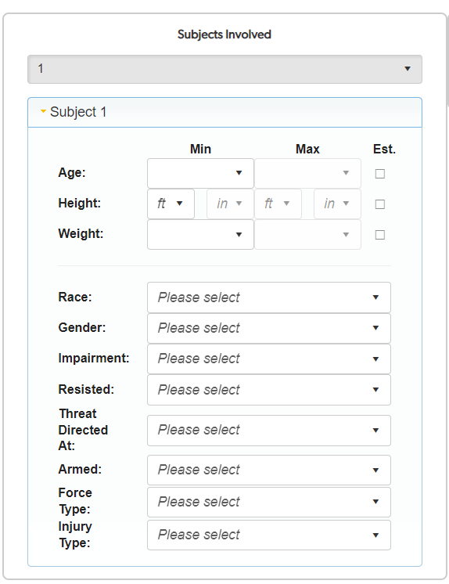
Upon selecting the number of subjects involved, the following fields will appear. Please respond to each field for each subject against whom force was applied.

Subject Age (Data Element S4)

Indicate age of subject.

Subject Height (Feet & Inches) (Data Elements S8 & S9)

Indicate subject’s height in feet and inches.

Subject Weight (Data Element 14)

Indicate subject’s weight in pounds.

Subject Race/Ethnicity (Data Element S2)

Indicate subject’s race or ethnicity.

Value | Description
H | Hispanic or Latino
A | Asian: A person having origins in any of the original peoples of the Far East,  Southeast Asia, or the Indian subcontinent including, for example, Cambodia, China, India, Japan, Korea, Malaysia, Pakistan, the Philippine Islands, Thailand, and Vietnam.
B | Black or African-American: A person having origins in any of the black racial groups of Africa.
I | American Indian or Alaskan Native: A person having origins in any of the original peoples of the Americas and maintaining cultural identification through tribal  affiliations or community recognition.
P | Native Hawaiian or Other Pacific Islander: A person having origins in any of the original peoples of Hawaii, Guam, Samoa, or other Pacific Islands. The term "Native Hawaiian" does not include individuals who are native to the State of Hawaii by virtue of being born there. However, the following Pacific Islander groups are included: Carolinian, Fijian, Kosraean, Melanesian, Micronesian, Northern Mariana Islander, Palauan, Papua New Guinean, Ponapean (Pohnpelan), Polynesian, Solomon Islander, Tahitian, Tarawa Islander, Tokelauan, Tongan, Trukese (Chuukese), and  Yapese.
W | White: A person having origins in any of the original peoples of Europe, North Africa, or Middle East.
PENDING | Pending further investigation
UNKNOWN | Unknown/Not Reported

Subject Gender/Sex (Data Element S3)

Indicate subject’s gender.

Value | Description
F | Female
M | Male
PENDING | Pending Further Investigation
UNKNOWN | Unknown/Not Reported

Impairment (Data Element S18)

Indicate if the Law Enforcement Officer felt the subject had an apparent or known impairment in mental or physical condition.

Value | Description
YES* | Yes
NO | No
PENDING | Pending further investigation
UNKNOWN | Unknown and is unlikely to ever be known
*If YES; indicate impairment.

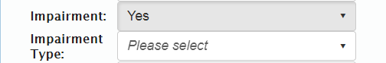

Impairment Type | Description
ALCOHOL | Alcohol impairment
DRUGS | Drug Impairment
MENTAL | Mental health condition
PENDING | Pending further investigation
UNKNOWN | Unknown and is unlikely to ever be known

Resisted (Data Element 20)

Indicate if the subject resisted during the incident.

Value | Description
YES* | Yes
NO | No
PENDING | Pending further investigation
UNKNOWN | Unknown and is unlikely to ever be known
*If YES; indicate resistance.
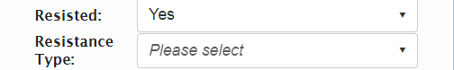

Resistance Type | Description
BARRICADE | Barricading self
ESCAPE_FLEE | Attempt to escape/flee from custody
FIREARM | Using a firearm against an officer or another
PHYSICAL | Using hands/fists/feet against an officer or another
DISPLAY_WEAPON | Displaying a weapon at an officer or another
BODY_FLUIDS | Intentionally spitting or bleeding on an officer
THROWING | Throwing an article or object at an officer
NONCOMPLIANCE | Failing to comply to verbal commands or other types of passive resistance
OTHER_WEAPON | Using another weapon (such as chemical agent,  edged weapons, electronic control weapon, or blunt object) against an officer or another
PENDING | Pending further investigation
RESISTED | Resisted being handcuffed or arrested
UNKNOWN | Unknown and is unlikely to ever be known
VERBAL | Making verbal threats
VEHICLE | Directing a vehicle at an officer or another

Threatened (Data Element 22)

Indicate to whom the subject’s threat was directed as perceived by the officer.

Threat Directed At? | Description
ANOTHER | Another party
BOTH | Both the officer and others
OFFICER | Officer
PENDING | Pending further investigation
UNKNOWN | Unknown and is unlikely to ever be known

Armed (Data Element 23)

Indicate if the law enforcement official felt the subject was armed during the incident with a weapon (other than hands, fists, and feet).

Value | Description
YES | Yes
NO | No
PENDING | Pending further investigation
UNKNOWN | Unknown and is unlikely to ever be known

Force Applied (Data Element 24)

Indicate if the force applied by the officer(s) of the incident is known, unknown or pending.

Value | Description
PENDING | Pending further investigation
UNKNOWN | Unknown and is unlikely to ever be known
KNOWN | Known
If force applied is ‘known,’ indicate the type of force used by the officer(s) on the subject during the incident. Multiple values can be provided within the data element.

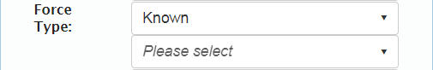

Force Type | Description
BATON | Baton
BLUNT_OBJECT | Blunt instrument/Flashlight
CANINE | Canine
CHEMICAL | Chemical agent/Pepper or OC (oleoresin capsicum) spray
ELECTRONIC | Electronic control weapon (Taser®)
EXPLOSIVE | Explosive device
FIREARM | Firearm
OTHER | Other
PENDING | Pending further investigation
PHYSICAL | Hands-fists-feet
PROJECTILE | Impact projectile
UNKNOWN | Unknown and is unlikely to ever be known

Injury Type (Data Element 25)

Indicate if the subject injury type is known, unknown, or pending investigation.

Value | Description
PENDING | Pending further investigation
UNKNOWN | Unknown and is unlikely to ever be known
NONE | No injury
OTHER* | Other (Specify)
*If Other; indicate type of injury.

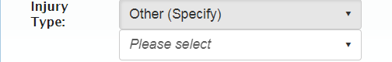

Indicate the type of injuries sustained by the subject. Multiple values can be provided within the data element.

Injury Type | Description
DEATH | Death
GUNSHOT | Gunshot Wound (including minor or grazing wounds)
NONE | None
OTHER_SERIOUS_INJURY | Serious injury requiring medical intervention or hospitalization
PENDING | Pending further investigation
UNCONSCIOUSNESS | Unconsciousness (regardless of duration)
UNKNOWN | Unknown and is unlikely to ever be known

Officer Details

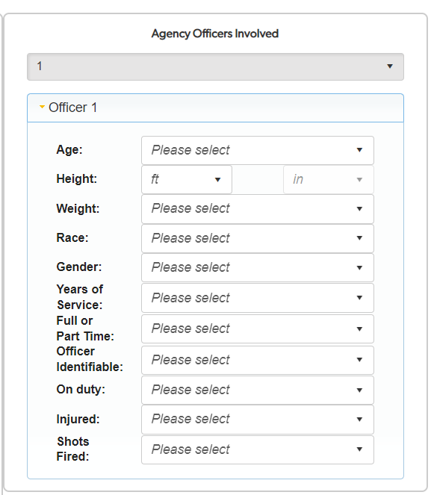
Upon selecting the number of officers that used force in the incident, the following fields will appear. Please respond to each field per officer that applied force.

Officer Age (Data Element O4)

Indicate age of officer.

Officer Height (Feet & Inches) (Data Elements O6 & O7)

Indicate officer’s height in feet and inches.

Officer Weight (Data Element O9)

Indicate officer’s weight in pound

Officer Race/Ethnicity (Data Element O2)

Indicate officer’s race or ethnicity.

Value | Description
H | Hispanic or Latino
A | Asian: A person having origins in any of the original peoples of the Far East, Southeast Asia, or the Indian subcontinent including, for example, Cambodia, China,  India, Japan, Korea, Malaysia, Pakistan, the Philippine Islands, Thailand, and Vietnam.
B | Black or African-American: A person having origins in any of the black racial groups of Africa.
I | American Indian or Alaskan Native: A person having origins in any of the original peoples of the Americas and maintaining cultural identification through tribal  affiliations or community recognition.
P | Native Hawaiian or Other Pacific Islander: A person having origins in any of the original peoples of Hawaii, Guam, Samoa, or other Pacific Islands. The term "Native Hawaiian" does not include individuals who are native to the State of Hawaii by virtue of being born there. However, the following Pacific Islander groups are included: Carolinian, Fijian, Kosraean, Melanesian, Micronesian, Northern Mariana Islander, Palauan, Papua New Guinean, Ponapean (Pohnpelan), Polynesian, Solomon Islander, Tahitian, Tarawa Islander, Tokelauan, Tongan, Trukese (Chuukese), and  Yapese.
W | White: A person having origins in any of the original peoples of Europe, North Africa, or Middle East.
PENDING | Pending further investigation
UNKNOWN | Unknown/Not Reported

Officer Gender/Sex (Data Element O3)

Indicate officer’s gender.

Value | Description
F | Female
M | Male
PENDING | Pending Further Investigation
UNKNOWN | Unknown/Not Reported

Officer Years of Service (Data Element O11)

Indicate the years of service the officer has as a law enforcement officer.

Full Time (Data Element O13)

Indicate if officer is employed full or part time. Full time is defined as 160 hours or more per month.

Value | Description
YES | Yes
NO | No
PENDING | Pending further investigation
UNKNOWN | Unknown and is unlikely to ever be known

Identifiable (Data Element O14)

Indicate if the officer was readily identifiable as an officer during the incident.

Value | Description
YES | Yes
NO | No
PENDING | Pending further investigation
UNKNOWN | Unknown and is unlikely to ever be known

On Duty (Data Element O15)

Indicate if the officer was on duty at time of incident.

Value | Description
YES | Yes
NO | No
PENDING | Pending further investigation
UNKNOWN | Unknown and is unlikely to ever be known

Injury Type (Data Element O16)

Indicate if the officer was injured (serious or minor) during the incident.

Value | Description
YES | Yes
NO | No
PENDING | Pending further investigation
UNKNOWN | Unknown and is unlikely to ever be known

Injuries incurred by officer during the incident. Multiple values can be provided.

Injury Type | Description
APPARENT_MINOR_INJURY | Other apparent Minor Injuries
DEATH | Death
GUNSHOT | Gunshot Wound (including minor or grazing wounds)
OTHER_SERIOUS_INJURY | Serious injury requiring medical intervention or hospitalization
PENDING | Pending further investigation
UNCONSCIOUSNESS | Unconsciousness
UNKNOWN | Unknown and is unlikely to ever be known

Shots Fired (Data Element O20)

Indicate whether the law enforcement officer discharged a firearm during the incident.

Value | Description
YES | Yes
NO | No
PENDING | Pending further investigation
UNKNOWN | Unknown and is unlikely to ever be known

Uploading an RMS generated file.

To submit data generated by the RMS, go to Show Me Crime web site.

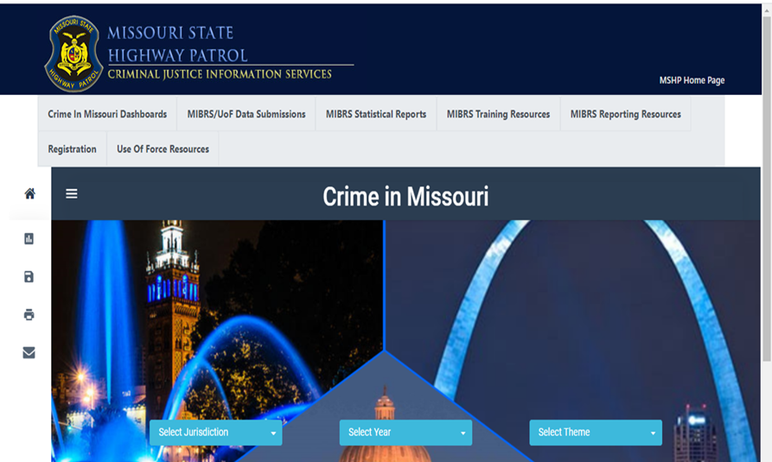

Then click on ‘MIBRS/UoF Data Submission.’

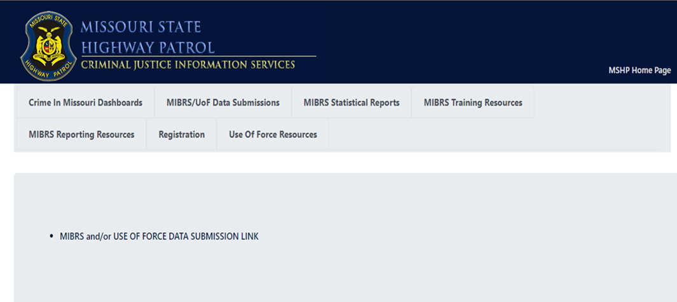

Then select ‘Use of Force Data Upload.’

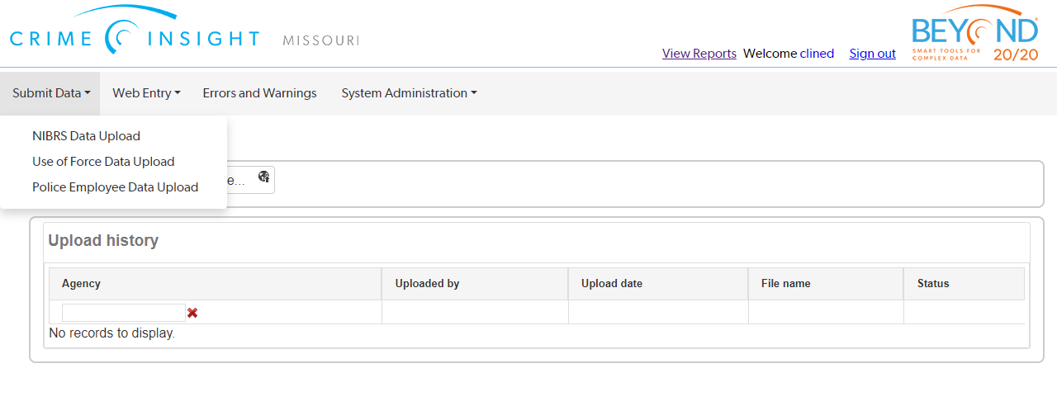
Then select ‘Choose File.’

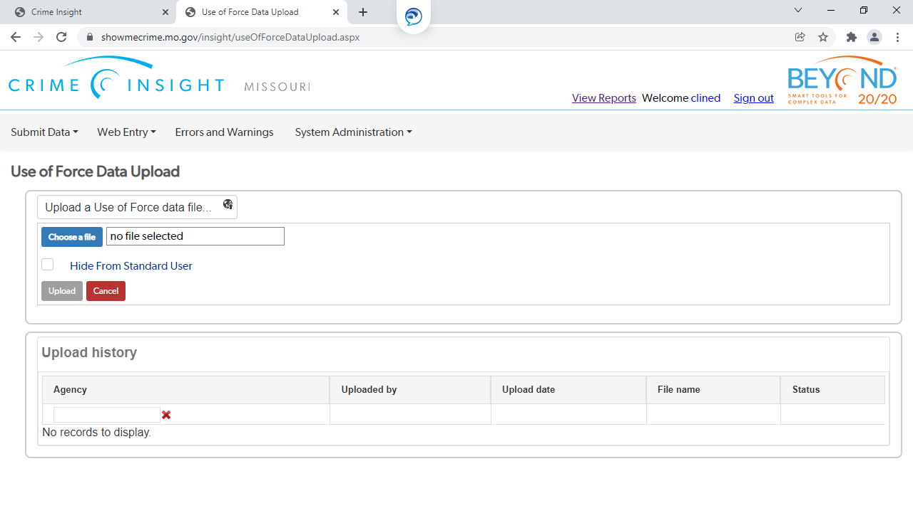

Find the file and select. Either by double clicking on the file or selecting ‘Open.’

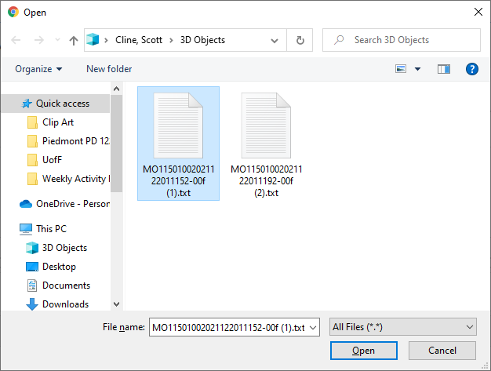

Then select ‘Upload.’

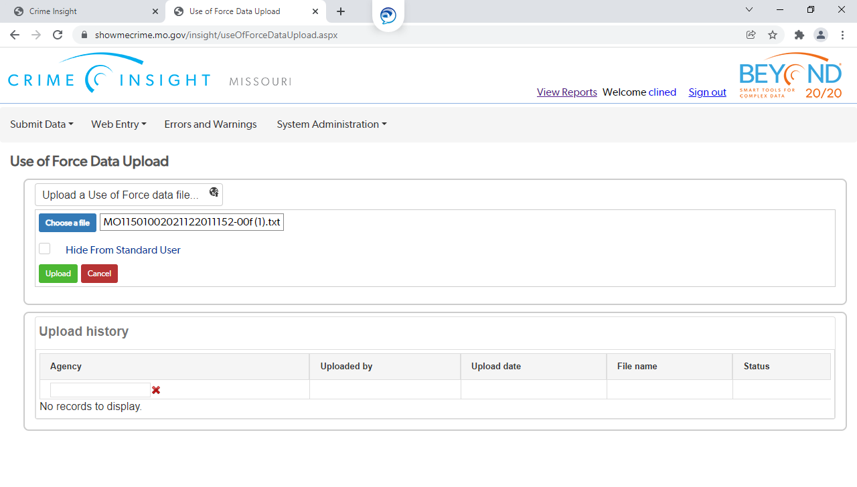

Submission and Error Correction


After entering all pertinent information, select ‘SUBMIT.’ At this point the information will be transferred to MSHP Use of Force repository.

To check the status of the submitted incident, look in the ‘Status’ column. (For both direct entry or file submission.)
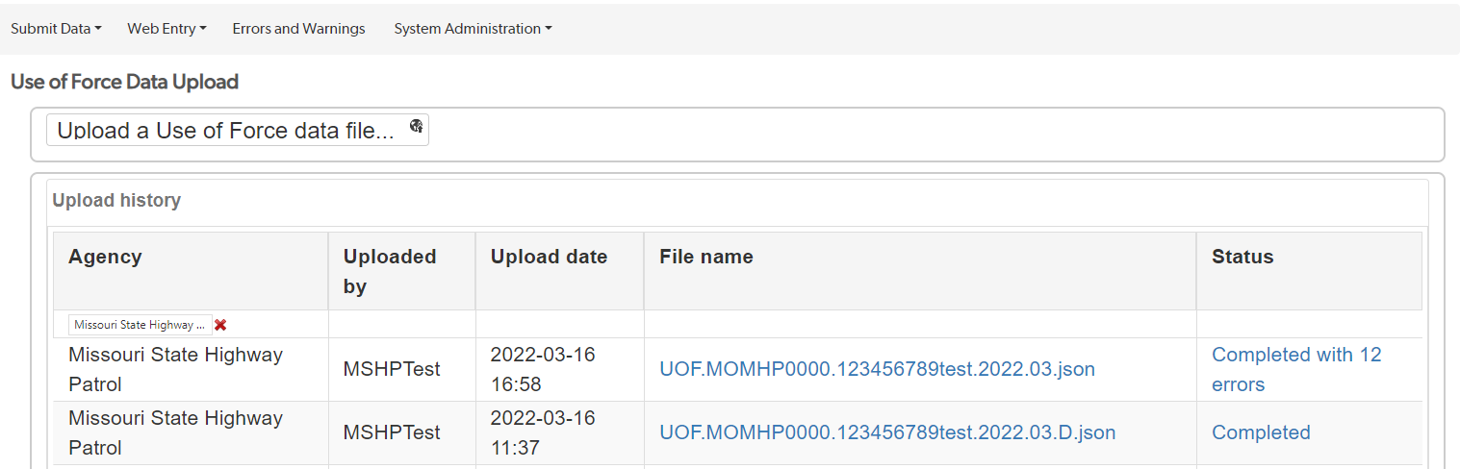

The system will return if the file was ‘Completed’ or ‘Completed with XX errors.’

The errors are listed; to open the incident for correction, click on the incident number.
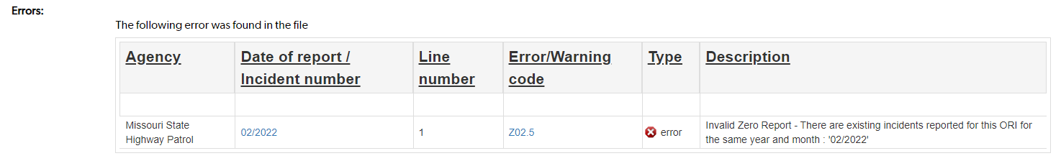

Each error will show in a red bold font at the top of the screen.
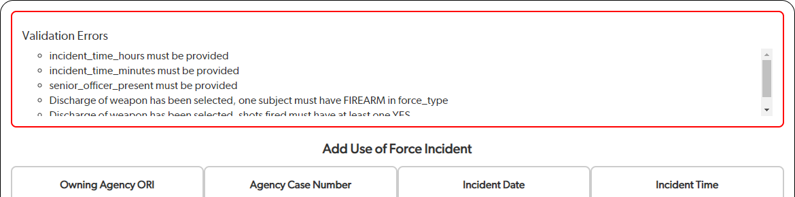

Based on the error, correct the incorrect information and select submit to resubmit the incident.

This process can be done repeatedly until the status reflects ‘Completed.’

